**ISMAIL 2nd Assignment**

1. **Explore environment variables and set aliases.**

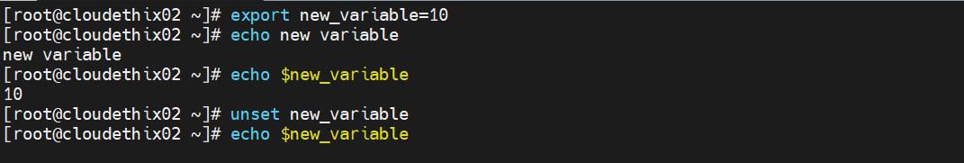

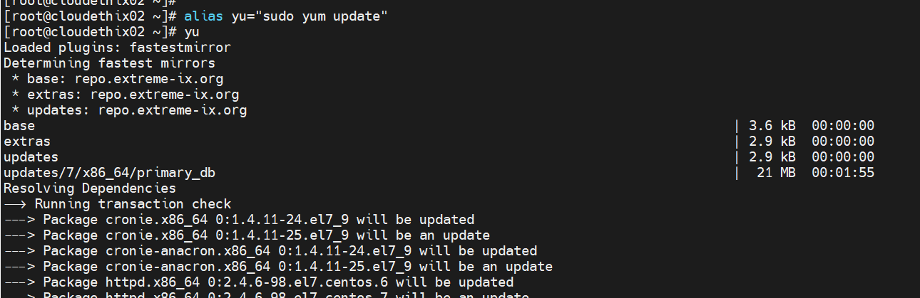

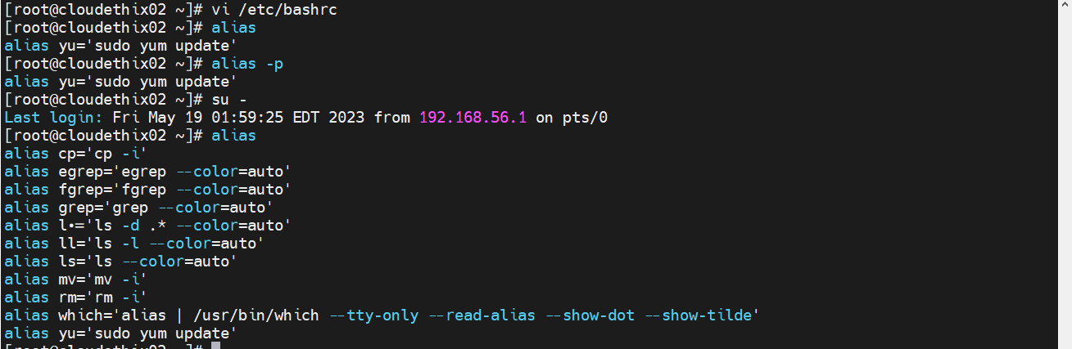

1. **Demonstrate archiving and compression (e.g., zip, tar, gzip, bzip2, zcat , zless , zmore ,**

**zgrep , bzcat , bzless, bzmore , bzgrep )**

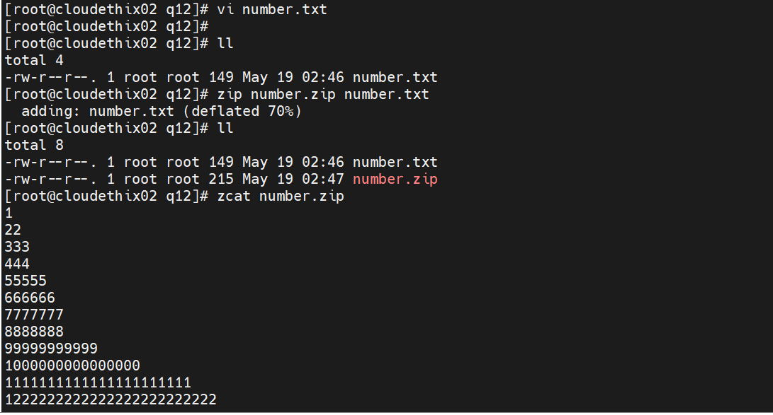

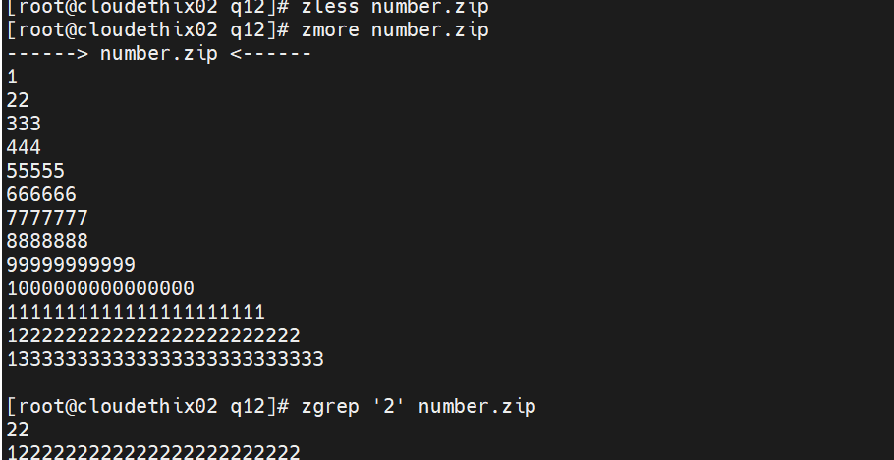

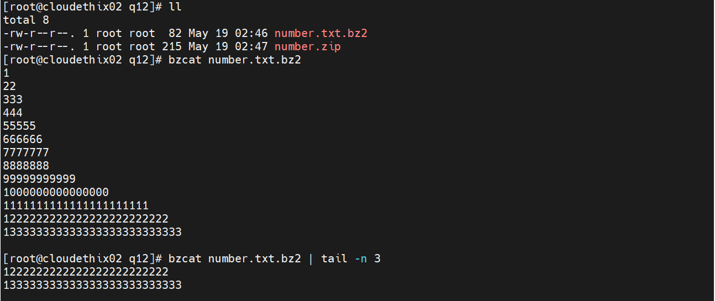

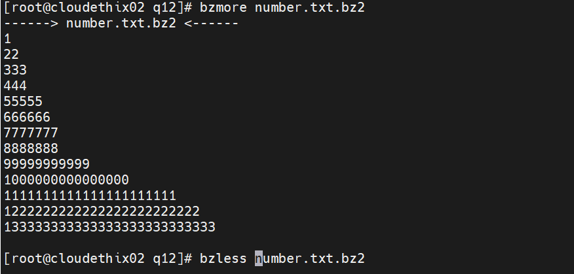

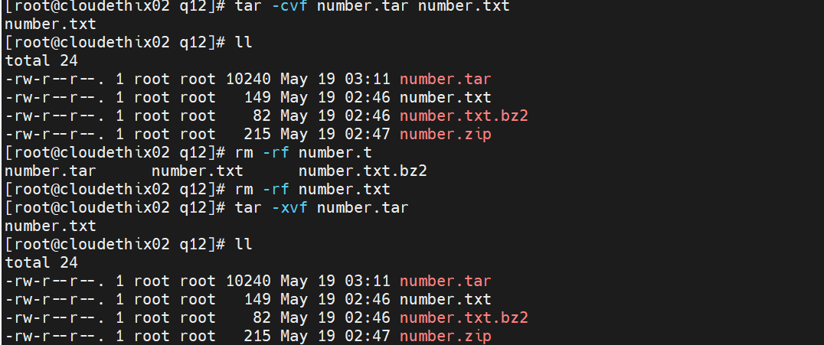

**13. Demonstrate about system logs and monitoring (e.g., dmesg, journalctl, tail,**

**dmidecode, biosdecode, lscpu, free).**

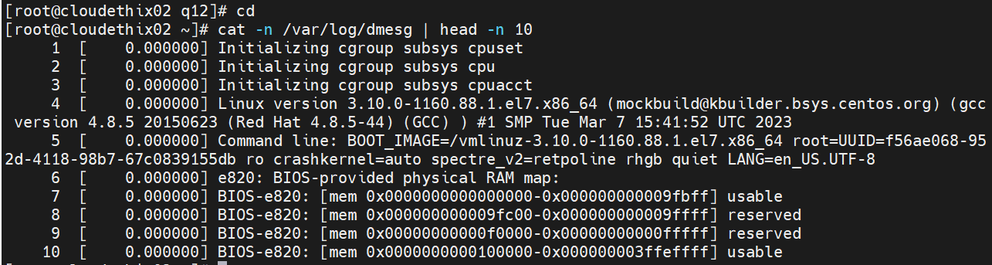

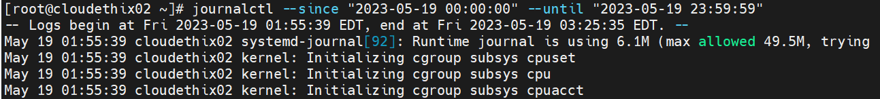

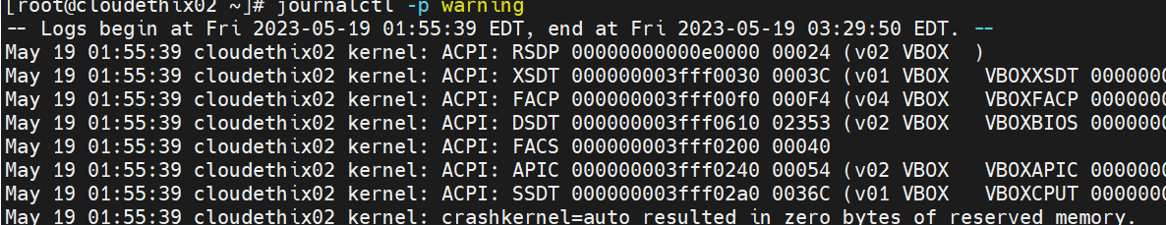

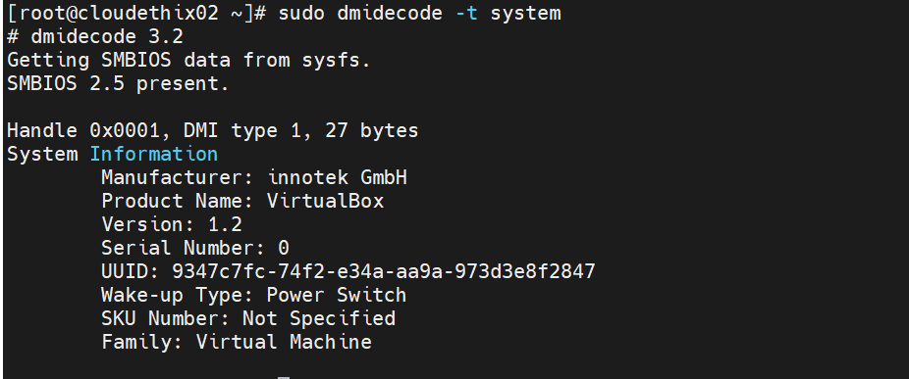

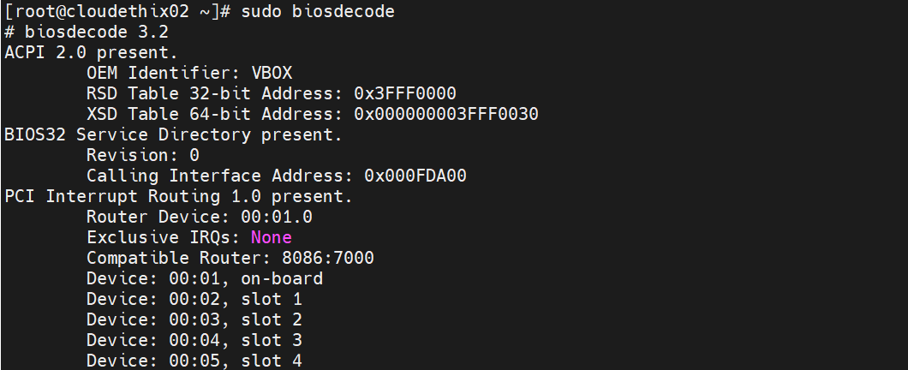

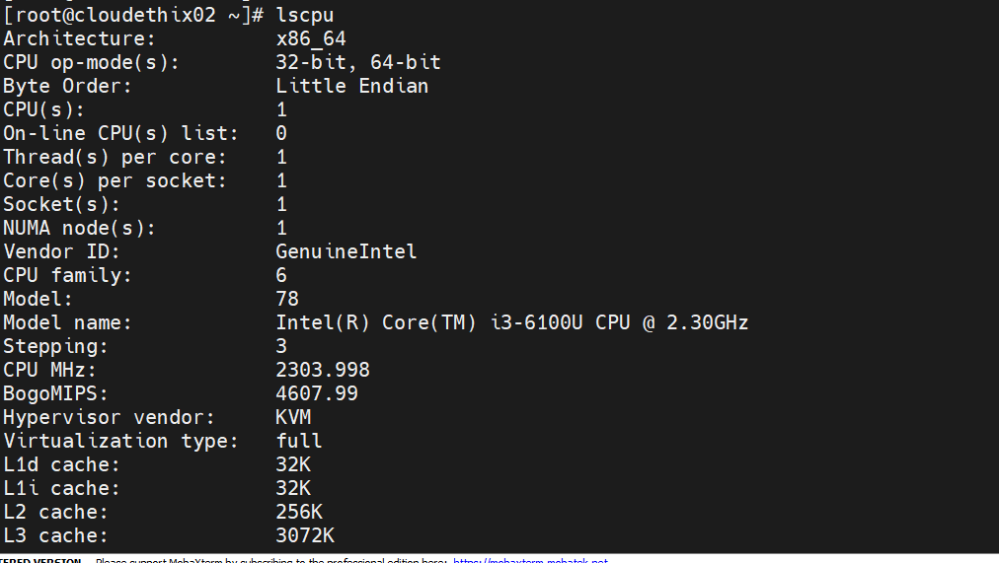



**4. Set up an SSH server and learn to use key-based authentication. Force password based**

**authentication. Check the SSH logs.**

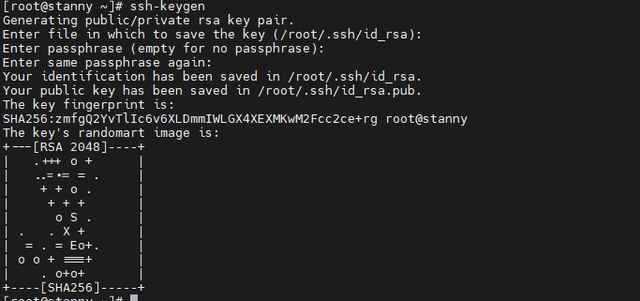

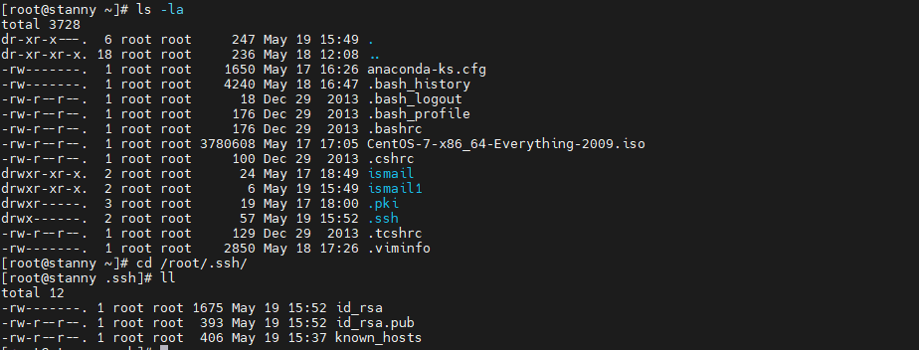



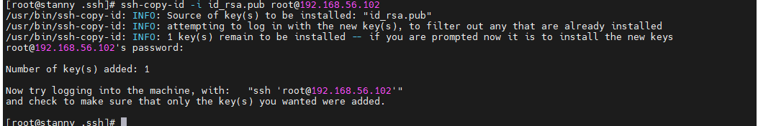

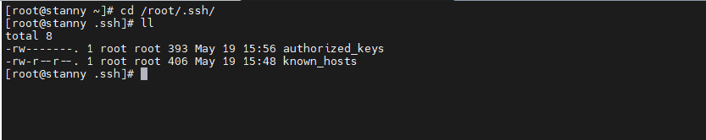



**5. Explore networking basics (e.g., ip, ifconfig, ping, traceroute, and netstat).**

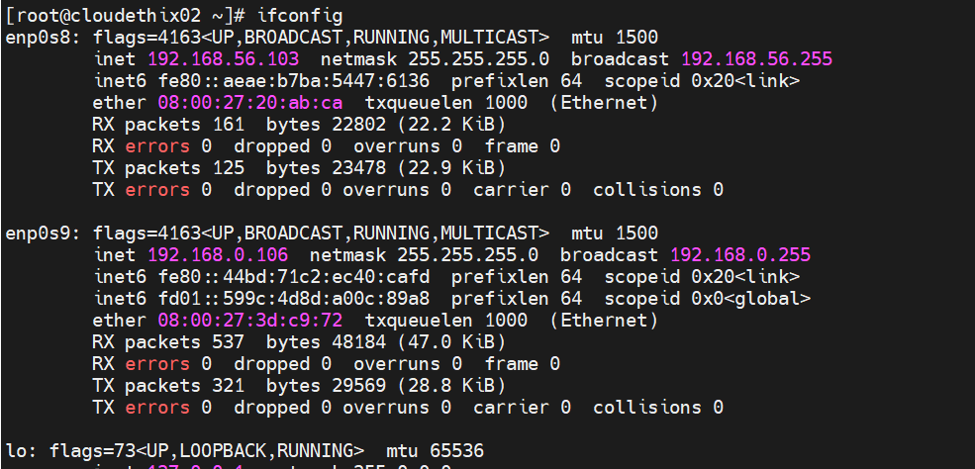

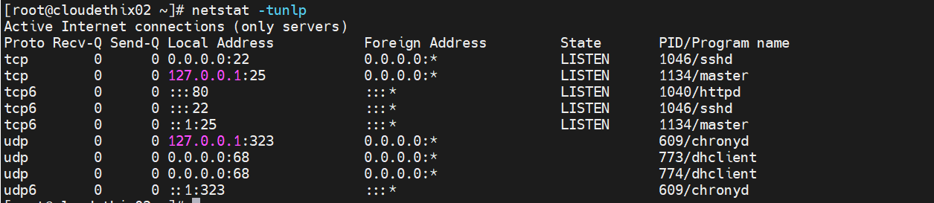

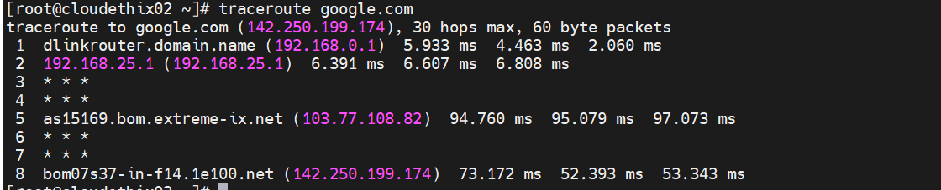

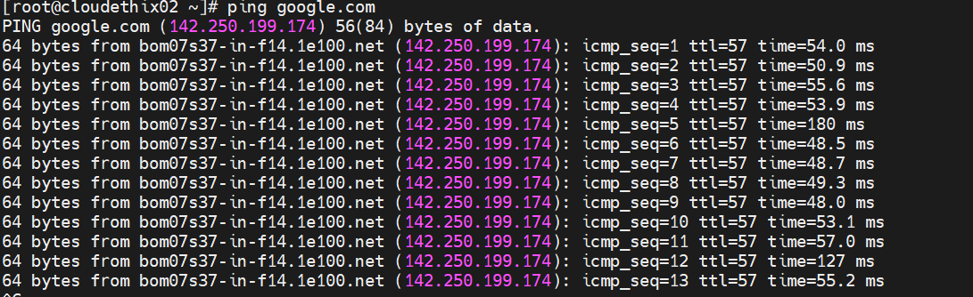

1. **Demonstrate to use DNS tools (e.g., dig and nslookup.)**

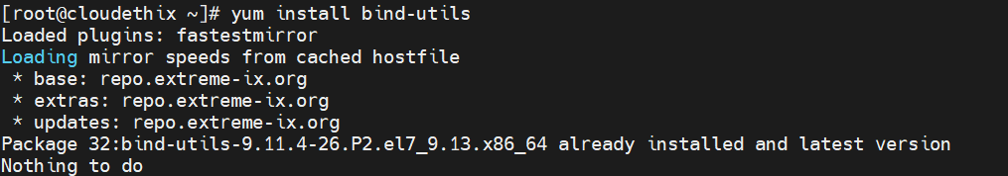

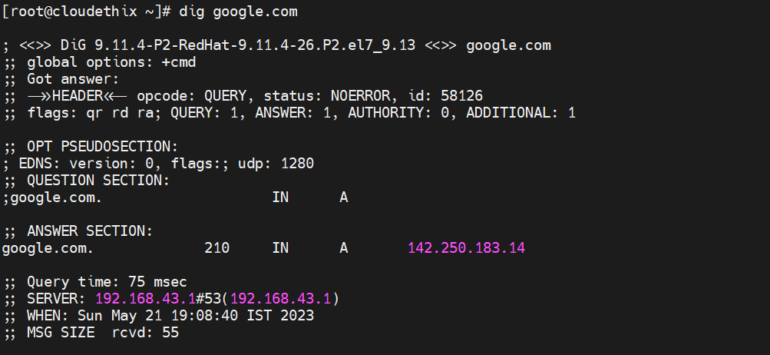

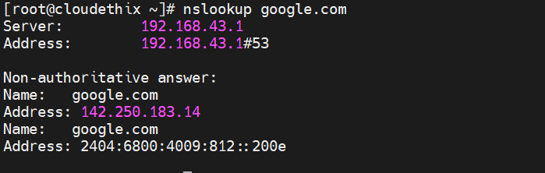

1. **Familiarize yourself with the cron job scheduling system & setup 5 cron jobs. Check the cron logs.**

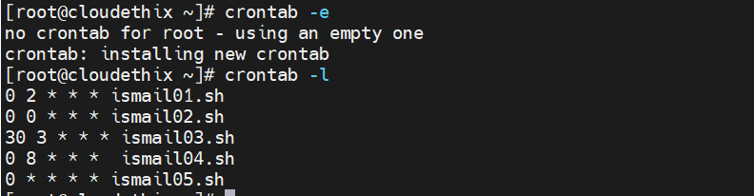

1. **Learn about disk and partition management (e.g., fdisk, parted, and df). Create partitions for each file system.**
2. **Explore file systems and mounting (e.g., ext2, ext3, ext4, xfs, and nfs). Format partitions accordingly with file system.**

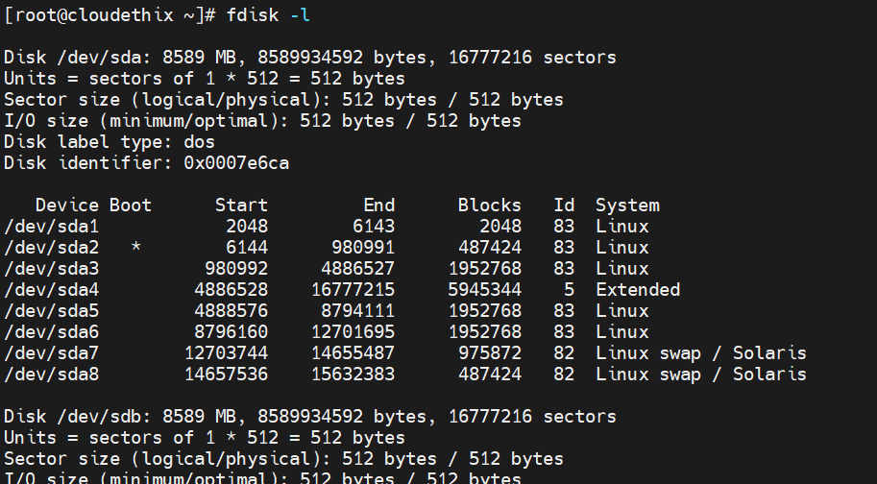

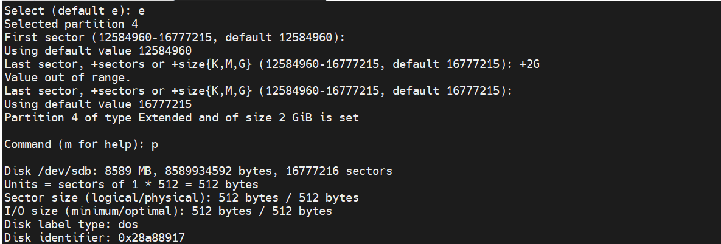

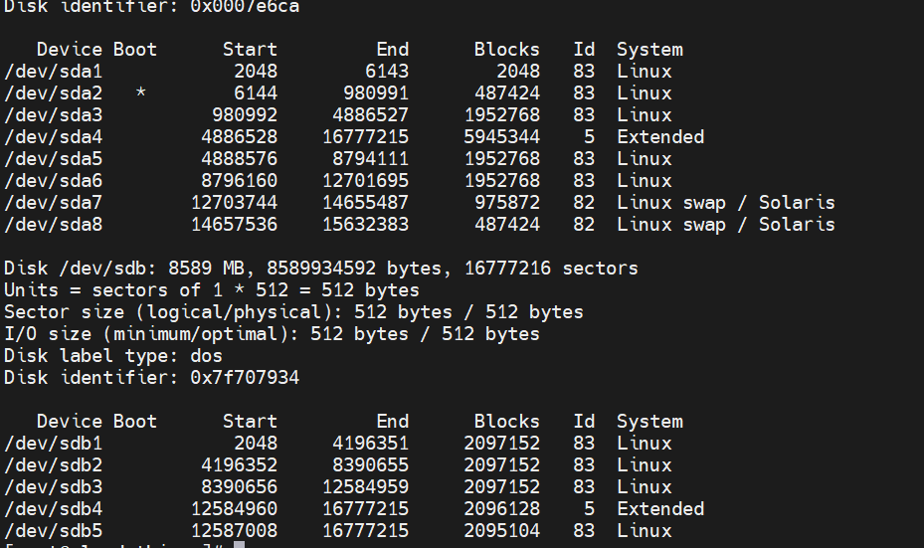

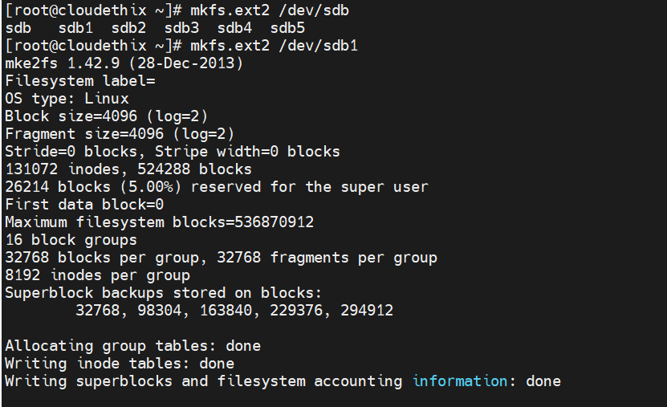

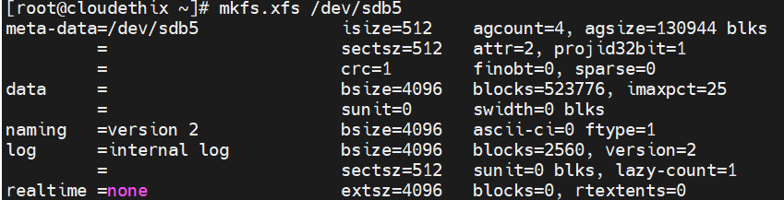

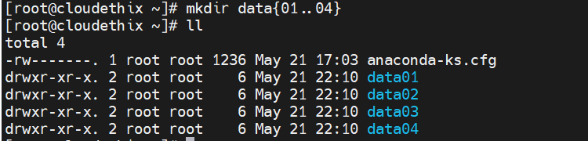

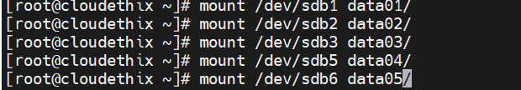

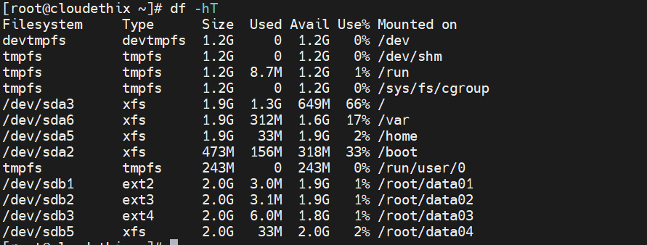

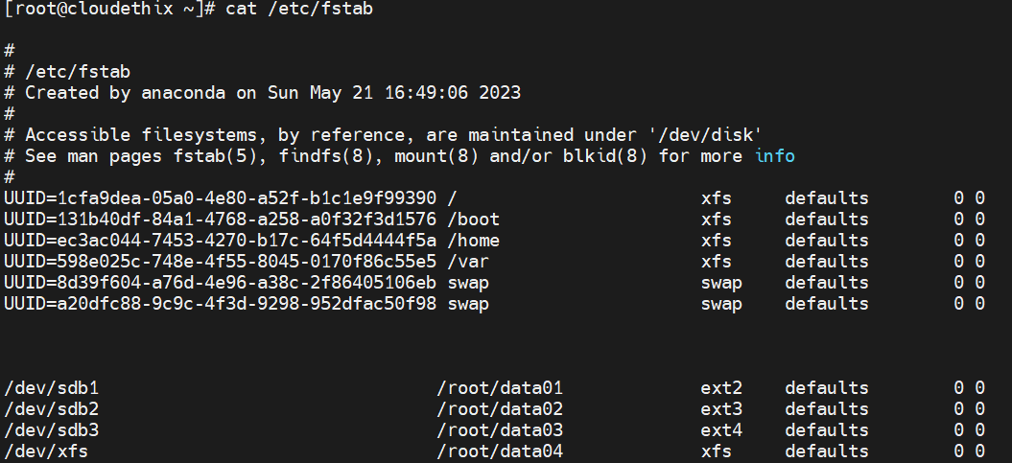

1. **Set up a basic LAMP (Linux, Apache, MySQL, PHP) stack.**

